- Task on CloudFront & Route 53
Task 1: Configure Cross-Region VPC Peering
Purpose
The purpose of this task is to establish private communication between two VPCs located in different AWS Regions using VPC Peering. This allows resources in both VPCs to communicate securely over the AWS global network without using the public internet, VPN, or Transit Gateway.
In this implementation, a VPC in N. Virginia (us-east-1) was connected to a VPC in Ohio (us-east-2) through a Cross-Region VPC Peering Connection. Route tables and security groups were updated to enable traffic flow between the VPCs.

Environment Details
Resource | Region | CIDR Block
VPC-A | N. Virginia (us-east-1) | 10.0.0.0/16
VPC-B | Ohio (us-east-2) | 20.0.0.0/16
Connection Type | Cross-Region VPC Peering | Active

Implementation Steps
Step 1: Create VPCs
Created two VPCs in different AWS Regions:
- VPC-A in N. Virginia with CIDR block 10.0.0.0/16
- VPC-B in Ohio with CIDR block 20.0.0.0/16

Step 2: Create VPC Peering Connection
- Opened the VPC Console in N. Virginia.
- Navigated to Peering Connections.
- Selected Create Peering Connection.
- Chose:
  - Requester VPC: VPC-A (N. Virginia)
  - Accepter VPC: VPC-B (Ohio)
- Created the peering request.

Step 3: Accept Peering Request
- Switched to the Ohio Region.
- Opened Peering Connections.
- Located the pending peering request.
- Accepted the request.
- Verified the peering connection status changed to Active.

Step 4: Update Route Tables
VPC-A Route Table (N. Virginia)
Added the following route:
Destination | Target
20.0.0.0/16 | VPC Peering Connection

VPC-B Route Table (Ohio)
Added the following route:
Destination | Target
10.0.0.0/16 | VPC Peering Connection

Step 5: Configure Security Groups
Updated security group rules to allow communication between both VPCs.
VPC-A Security Group
Type | Source
ICMP | 20.0.0.0/16
SSH (Optional) | 20.0.0.0/16

VPC-B Security Group
Type | Source
ICMP | 10.0.0.0/16
SSH (Optional) | 10.0.0.0/16

Step 6: Verify Connectivity
Launched EC2 instances in both VPCs and tested connectivity using private IP addresses.
Verification methods:
- Ping Test
- SSH Connectivity Test
- Route Table Validation
- Peering Connection Status Validation

Result
Successfully established a Cross-Region VPC Peering Connection between VPC-A in N. Virginia and VPC-B in Ohio. Route tables and security groups were configured to allow secure communication between resources in both VPCs using private IP addresses over the AWS backbone network.

Architecture
N. Virginia (us-east-1)
--------------------------------
VPC-A
CIDR: 10.0.0.0/16
|
|
| Cross-Region VPC Peering
|
|
Ohio (us-east-2)
--------------------------------
VPC-B
CIDR: 20.0.0.0/16
Outcome
The cross-region peering connection was successfully configured, enabling secure and private communication between the two VPCs without traversing the public internet. This architecture improves security, reduces network complexity, and supports inter-region application communication.

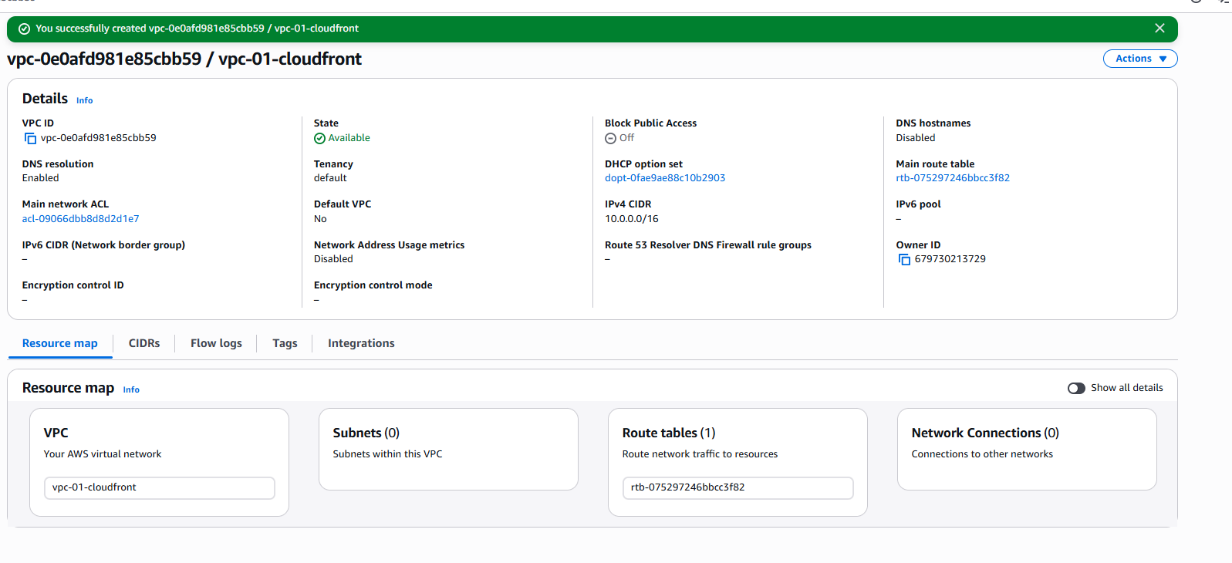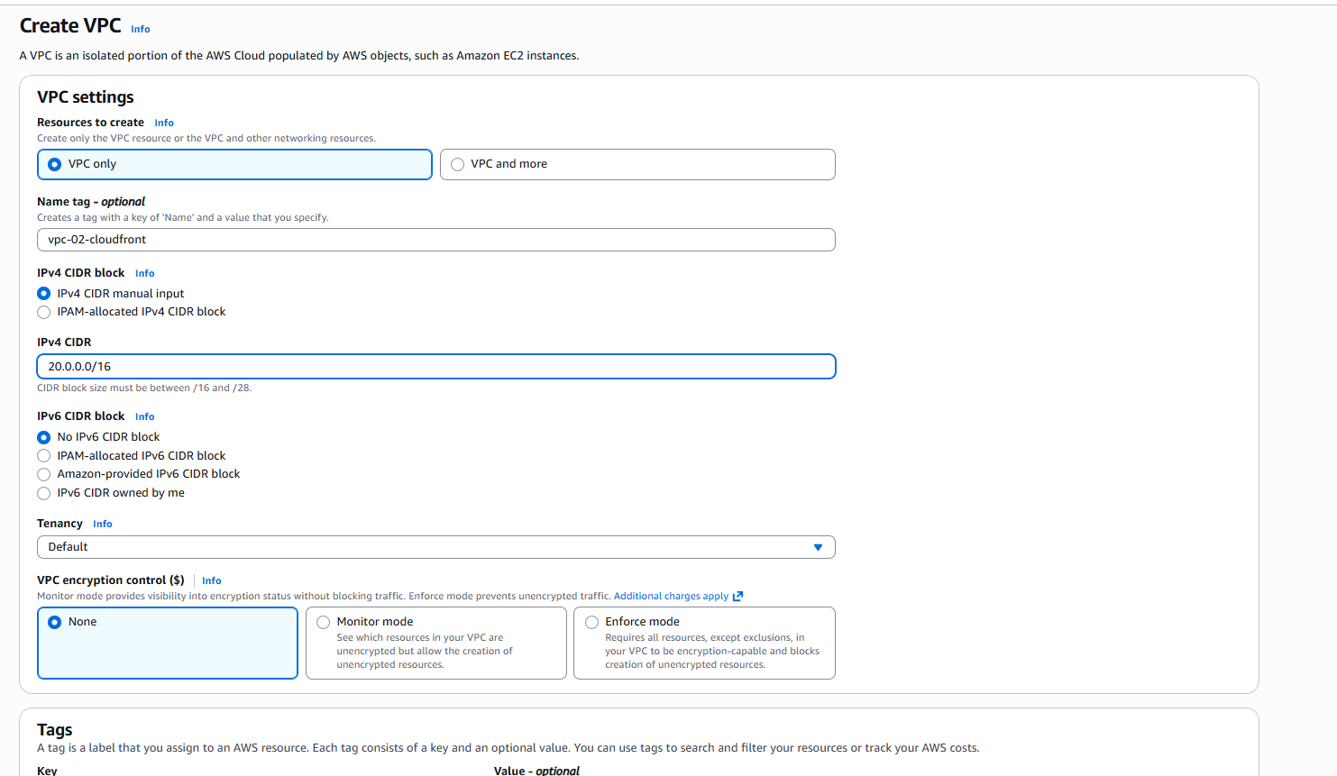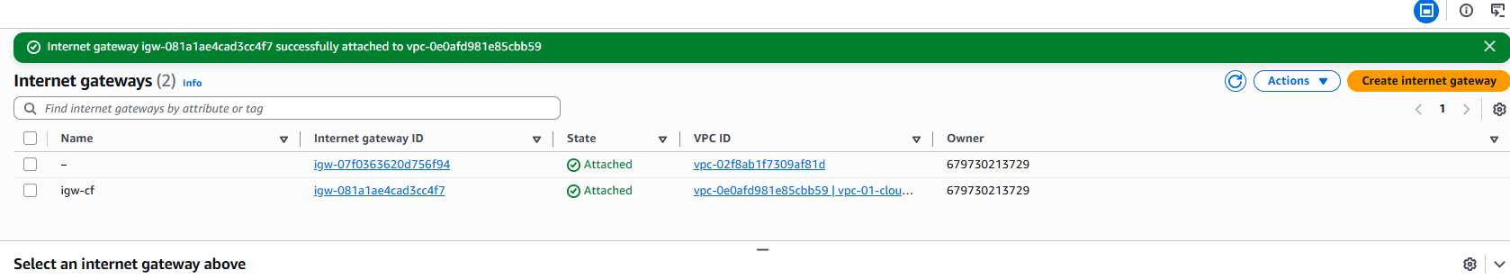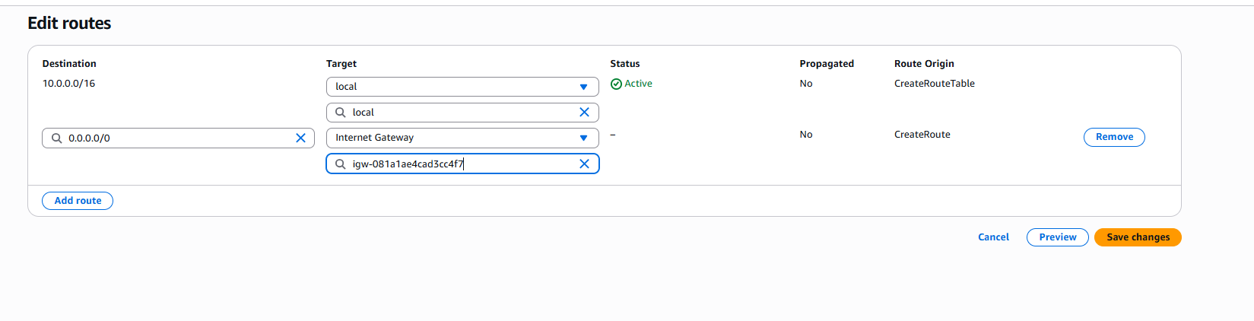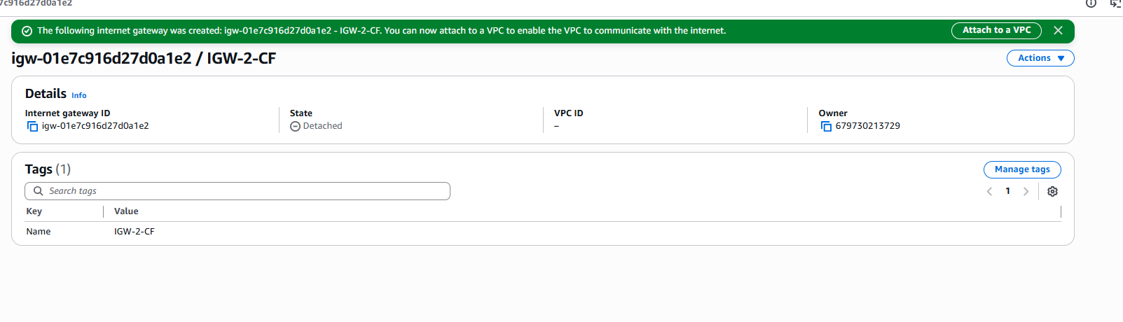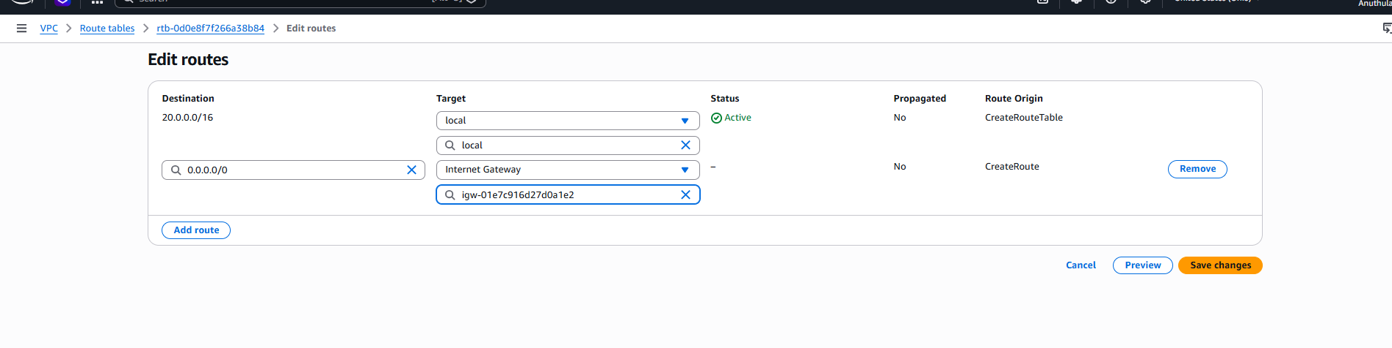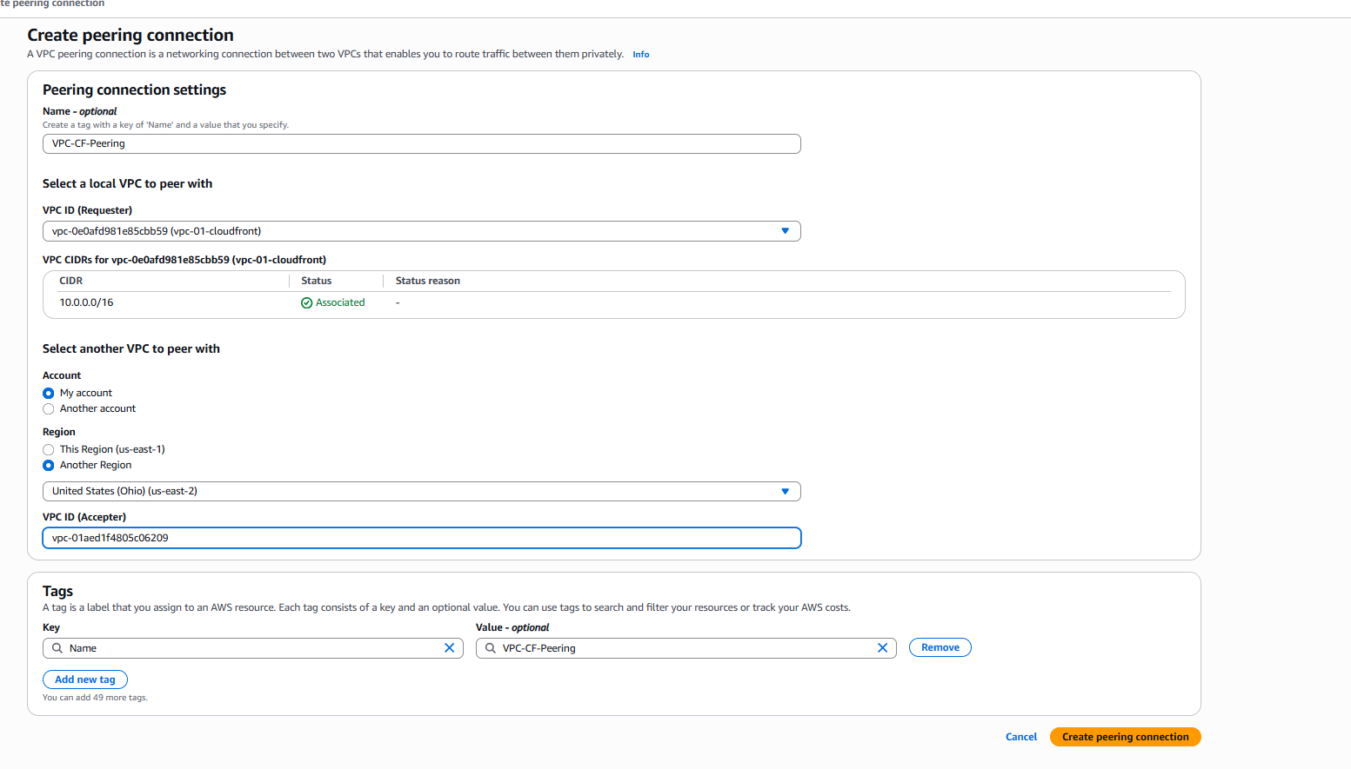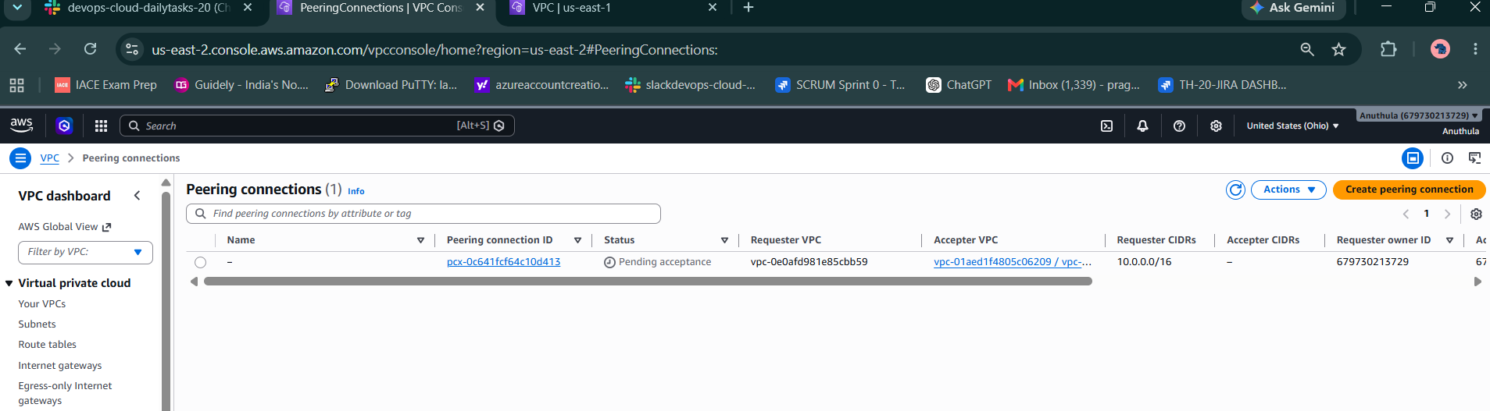v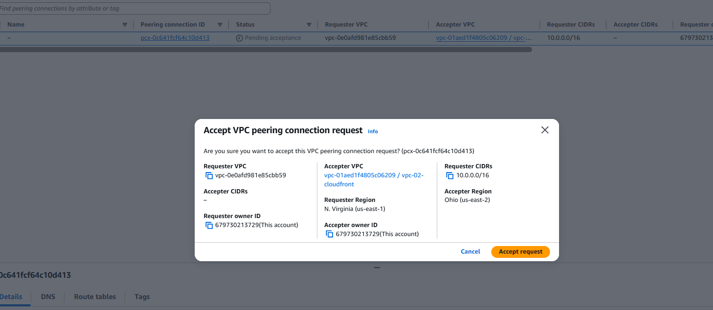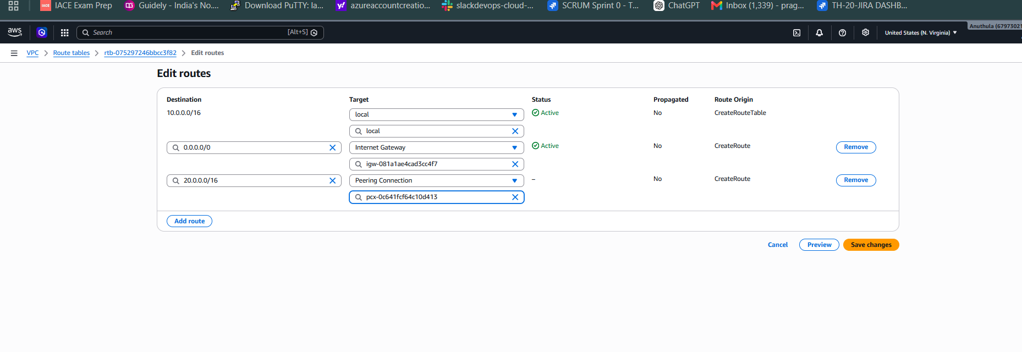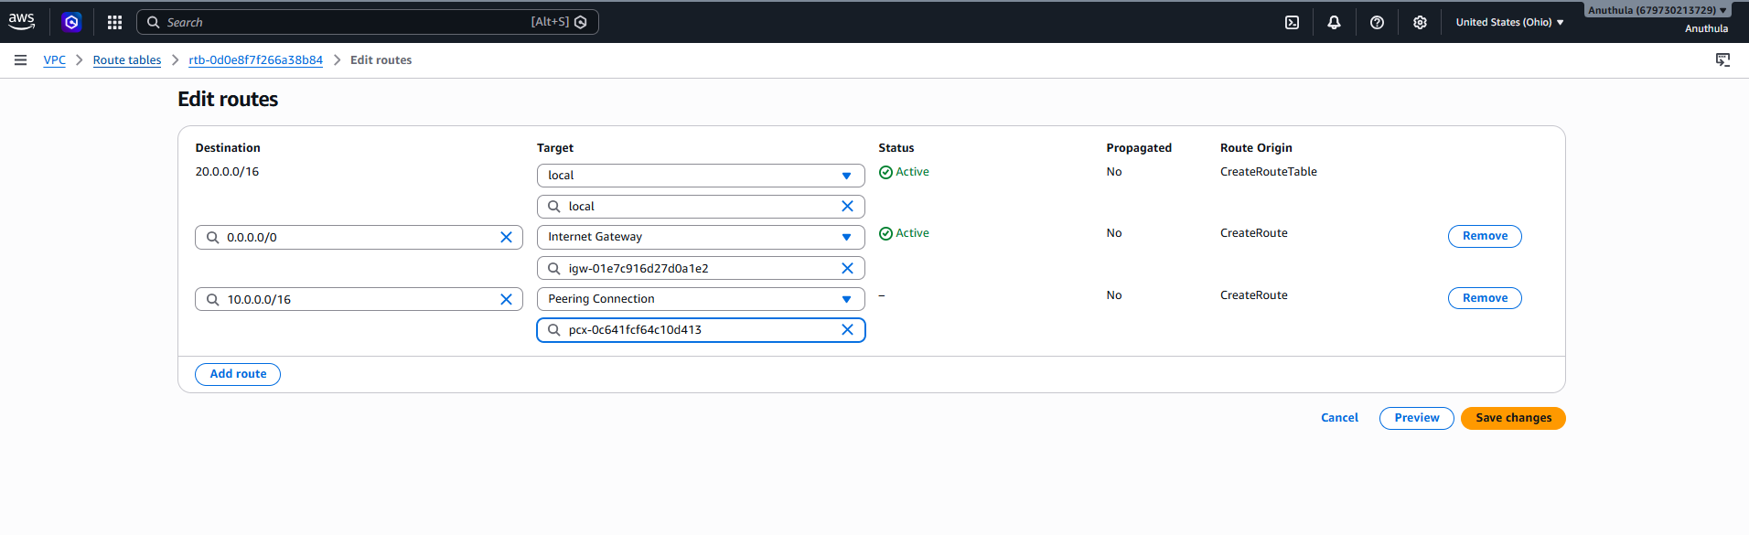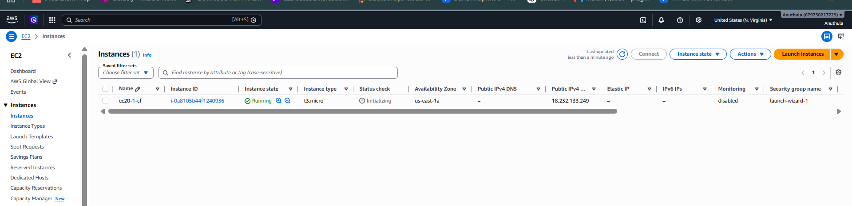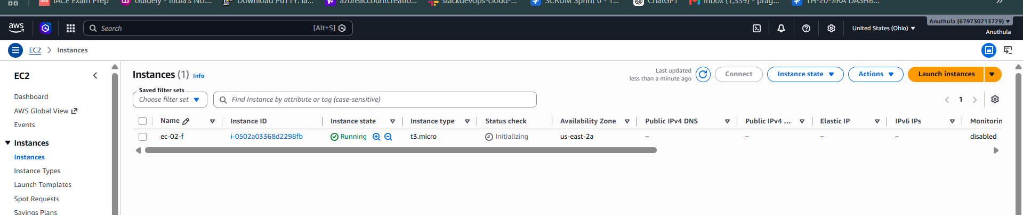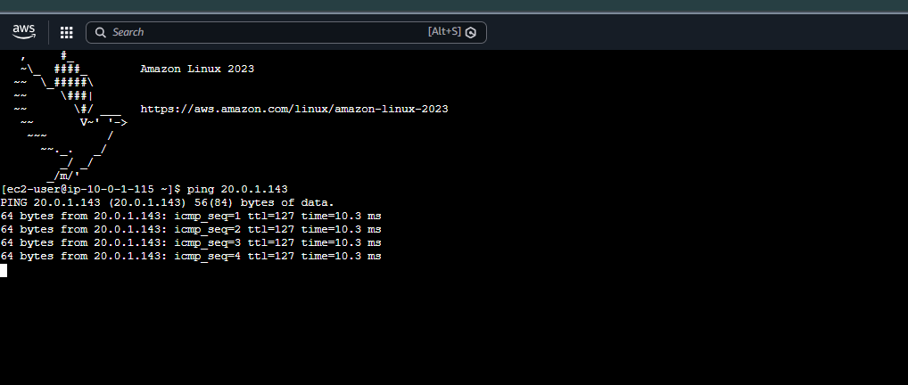
Task 2: Purchase a Domain from GoDaddy
Objective
The objective of this task was to purchase and register a domain name using GoDaddy. A domain name provides a unique identity on the internet and can be used to host websites, applications, email services, and cloud resources.

Domain Purchased
sashadevopsdemo.shop

Implementation Steps
Step 1: Accessed GoDaddy
Logged in to the GoDaddy account using valid credentials to access domain registration services.
Purpose:
GoDaddy is a domain registrar that allows users to search, purchase, and manage domain names.
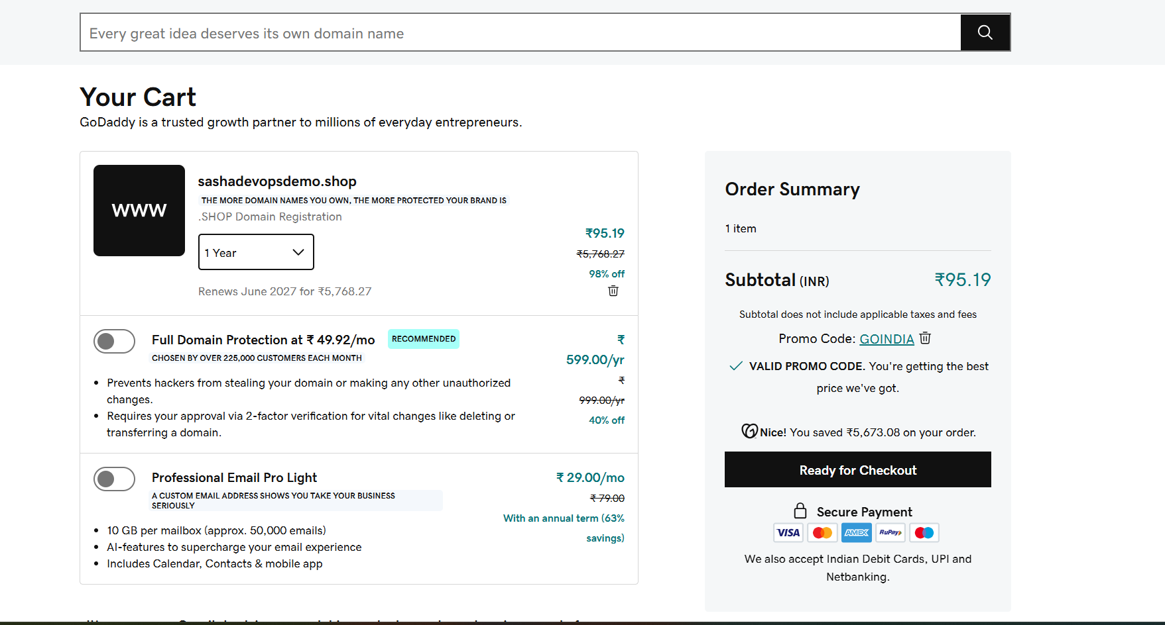

Step 2: Searched for Domain Availability
Entered the desired domain name sashadevopsdemo.shop in the domain search bar.
Purpose:
This step verifies whether the selected domain name is available for registration and not already owned by another user.

Step 3: Selected the Domain
After confirming availability, the domain was added to the shopping cart.
Purpose:
Adding the domain to the cart reserves it temporarily and allows the registration process to continue.

Step 4: Selected Registration Period
Chose a registration duration of 1 year.
Purpose:
The registration period determines how long ownership of the domain is maintained before renewal is required.

Step 5: Reviewed Optional Services
Reviewed additional services such as:
- Domain Protection
- Professional Email
- Website Hosting
These services were not selected for this task.
Purpose:
Optional services provide additional security and business features but are not mandatory for domain registration.

Step 6: Applied Promotional Discount
A promotional code (GOINDIA) was automatically applied, reducing the registration cost.
Purpose:
Promotional codes help reduce the overall cost of domain registration.

Step 7: Reviewed Order Summary
Verified:
- Domain Name
- Registration Period
- Pricing Details
Purpose:
Ensures that the correct domain and pricing information are selected before payment.

Step 8: Completed Payment
Proceeded to checkout and completed the payment process.
Purpose:
Payment confirms ownership and activates the domain registration.

Step 9: Verified Domain Registration
After successful payment, the domain was verified under:
GoDaddy → My Products → Domains
Purpose:
Verification confirms that the domain has been successfully registered and is ready for use.

Result
The domain sashadevopsdemo.shop was successfully registered through GoDaddy for a one-year period. The domain is now available for DNS management, website hosting, email configuration, and integration with cloud services.

Conclusion
This task demonstrated the process of purchasing and registering a domain name using GoDaddy. The registered domain can now be used as a public-facing address for websites, applications, and other internet-based services.
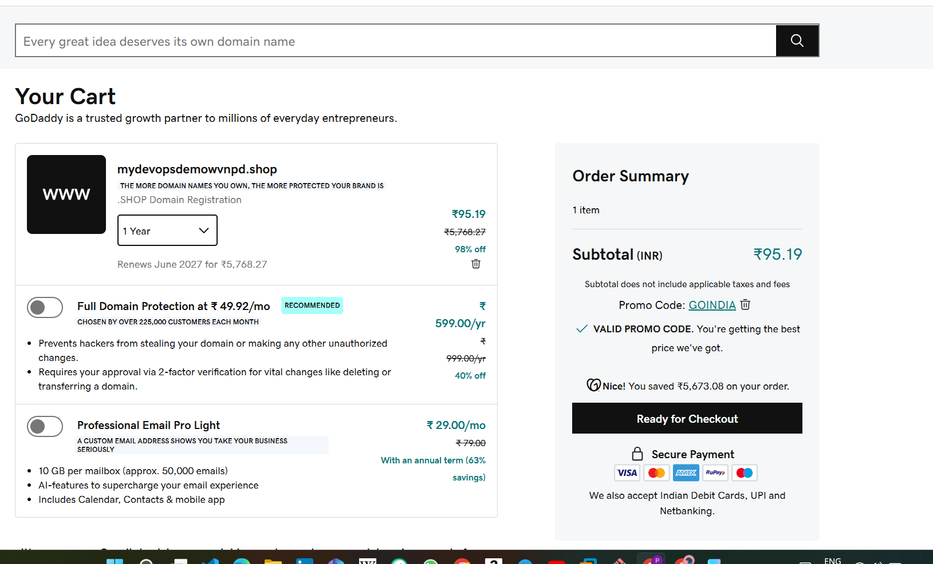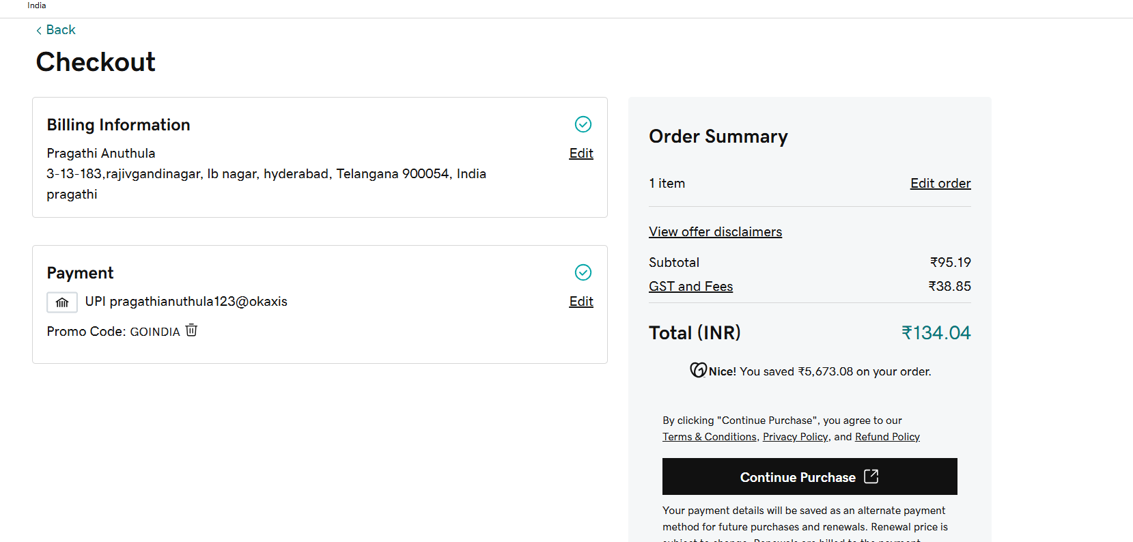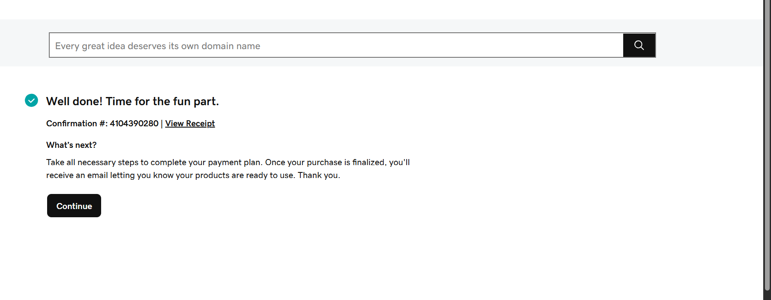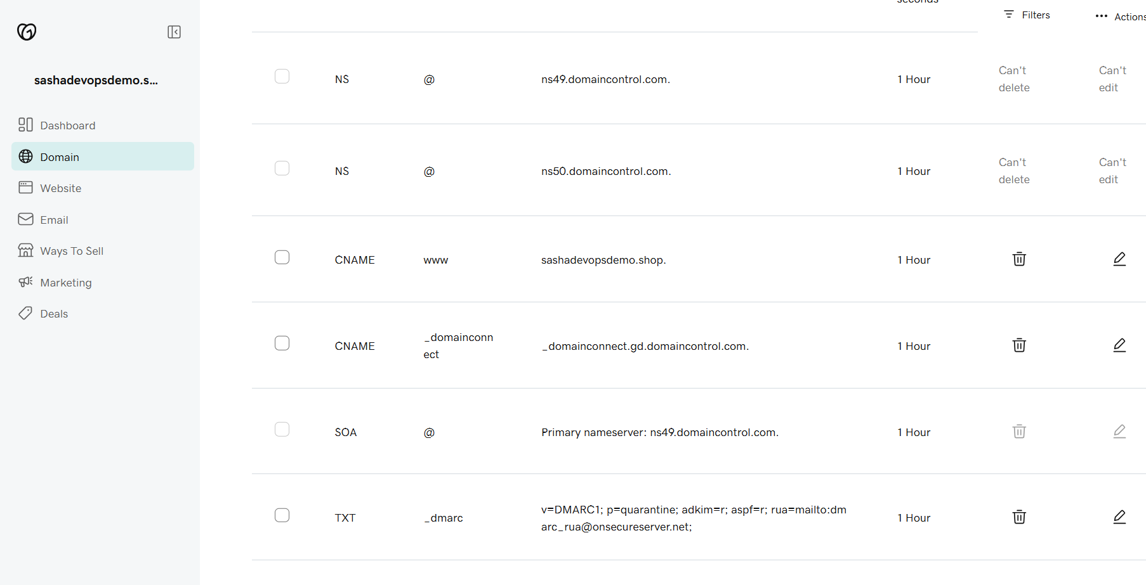

Task 3: Deploy Static Website in Amazon S3
Objective
Deploy a simple static website using Amazon S3. A static website contains files like HTML, CSS, JavaScript, and images. S3 can host these files and make the website publicly accessible through an S3 website endpoint.
Steps to Deploy
Step 1: Create an S3 Bucket
- Login to AWS Console.
- Search for S3.
- Click Create bucket.
- Enter a unique bucket name.
Example:
sashadevopsdemo-website
- Select your AWS Region.
- Keep other settings default for now.
- Click Create bucket.
Step 2: Upload Website Files
Prepare simple website files:
index.html
<!DOCTYPE html>
<html>
<head>
<title>Sasha DevOps Demo</title>
</head>
<body>
<h1>Welcome to Sasha DevOps Demo Website</h1>
<p>This static website is hosted on Amazon S3.</p>
</body>
</html>
Upload this file into the S3 bucket.
Step 3: Enable Static Website Hosting
- Open your S3 bucket.
- Go to Properties.
- Scroll down to Static website hosting.
- Click Edit.
- Select Enable.
- Choose Host a static website.
- Enter:
Index document: index.html
Error document: index.html
- Click Save changes.
Step 4: Allow Public Access
- Go to the bucket Permissions tab.
- Click Block public access.
- Click Edit.
- Uncheck Block all public access.
- Confirm by typing:
confirm
- Click Save changes.
Step 5: Add Bucket Policy
In the Permissions tab, go to Bucket policy and add this policy.
Replace your-bucket-name with your actual bucket name.
{
"Version": "2012-10-17",
"Statement": [
{
"Sid": "PublicReadGetObject",
"Effect": "Allow",
"Principal": "*",
"Action": "s3:GetObject",
"Resource": "arn:aws:s3:::your-bucket-name/*"
}
]
}
Example:
"Resource": "arn:aws:s3:::sashadevopsdemo-website/*"
Step 6: Open Website Endpoint
- Go to Properties.
- Scroll to Static website hosting.
- Copy the Bucket website endpoint.
- Paste it in your browser.
Your website should open successfully.
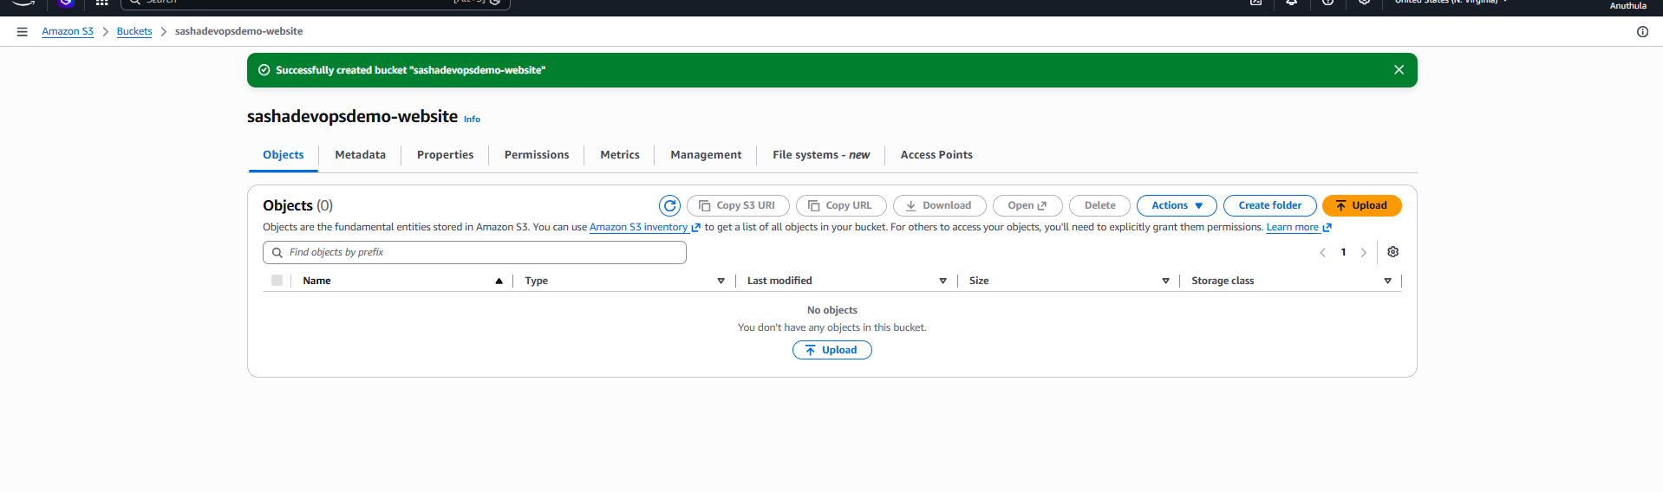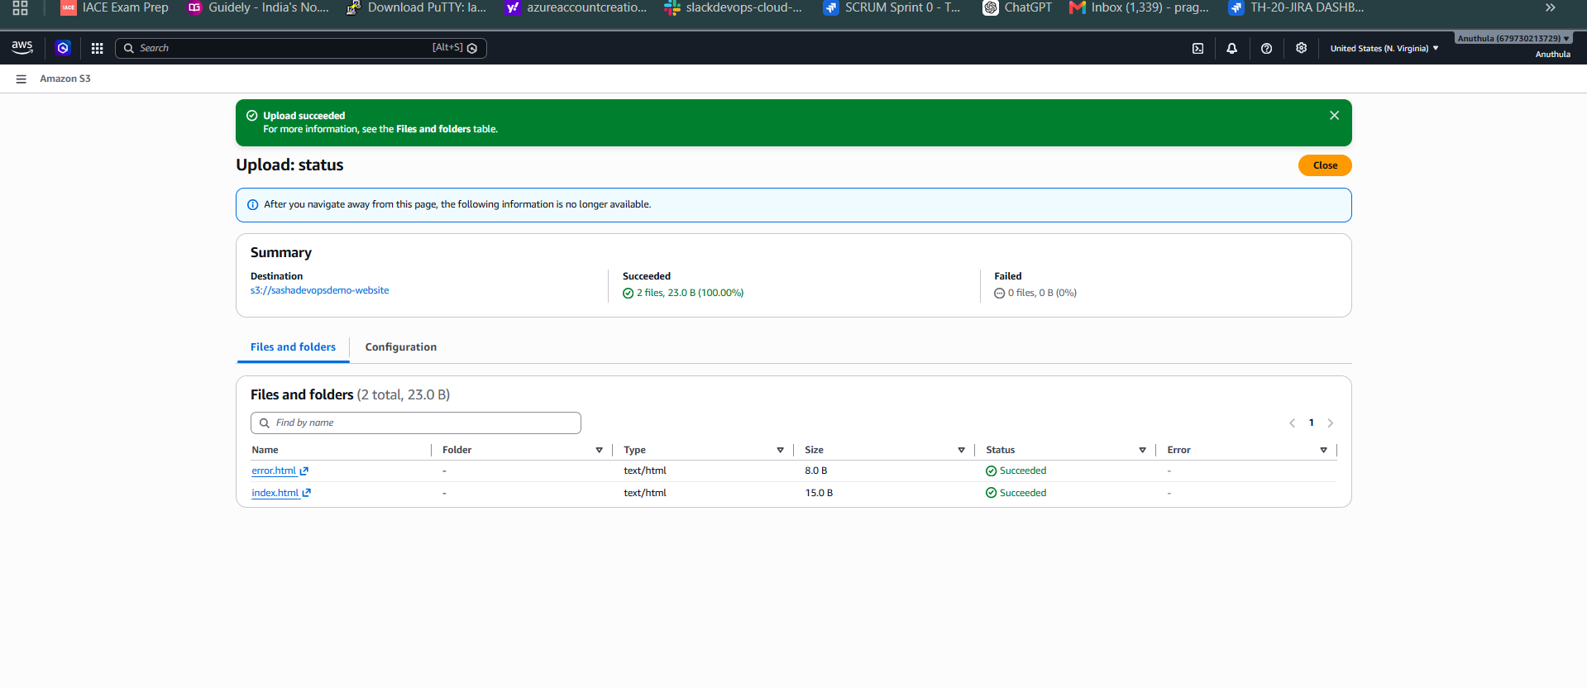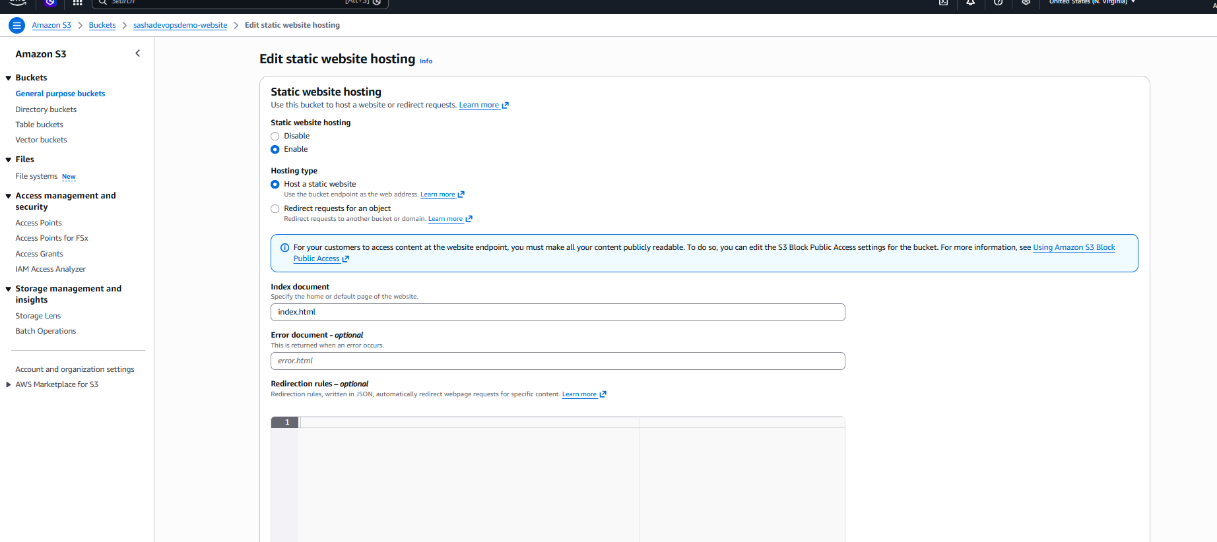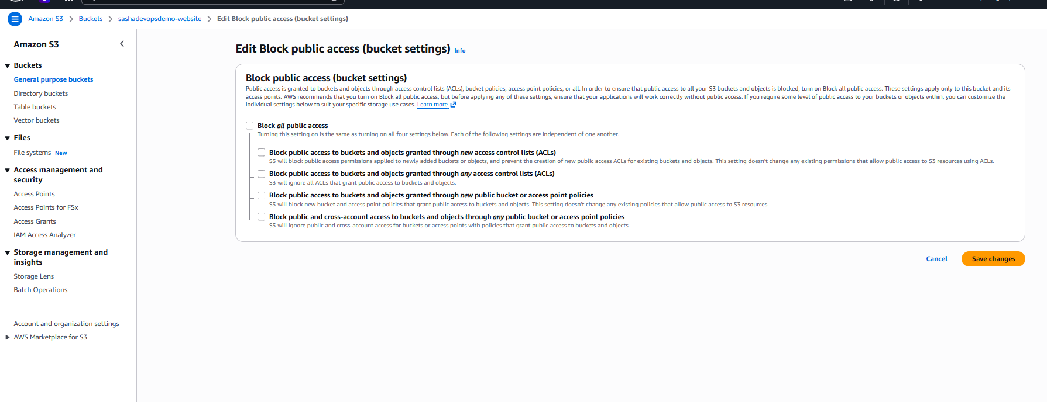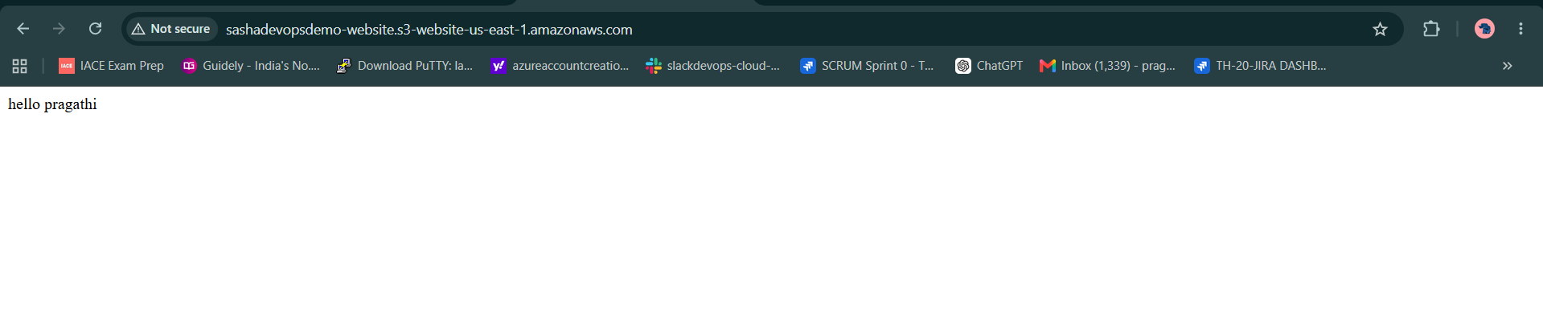
Task 4: Create a CDN and Attach an SSL Certificate, the most common AWS implementation is:
Amazon CloudFront (CDN) + AWS Certificate Manager (ACM SSL Certificate) + S3 Static Website
Since your previous task was hosting a static website in S3, this task naturally follows.
Objective
Create a CloudFront Distribution (CDN) for the S3-hosted website and attach an SSL certificate so the website can be accessed securely using HTTPS.

Architecture
User
|
HTTPS
|
CloudFront Distribution
|
S3 Bucket (Static Website)

Step 1: Request SSL Certificate
Navigate to ACM
- Login to AWS Console.
- Search for Certificate Manager.
- Open ACM.
Important
For CloudFront, the certificate must be created in:
US East (N. Virginia)
us-east-1
Switch region if needed.

Request Certificate
- Click Request Certificate.
- Select:
Request a public certificate
- Click Next.

Enter Domain Name
If you purchased:
sashadevopsdemo.shop
Add:
sashadevopsdemo.shop
*.sashadevopsdemo.shop
Click Request.
Purpose:
- Main domain
- All subdomains

Step 2: Validate Certificate
ACM provides DNS records.
Example:
Name:
_abcd123.sashadevopsdemo.shop
Value:
_xyz.acm-validations.aws

Add DNS Record in GoDaddy
- Login to GoDaddy.
- Open Domain Management.
- Select your domain.
- Open DNS Management.
- Click Add Record.
Choose:
Type: CNAME
Enter ACM values.
Save.

Wait for Validation
Usually:
5–30 minutes
Certificate status changes to:
Issued

Step 3: Create CloudFront Distribution
- Search CloudFront.
- Click Create Distribution.

Origin Settings
Origin Domain:
Select your S3 bucket.
Example:
sashadevopsdemo-website.s3.amazonaws.com

Viewer Protocol Policy
Select:
Redirect HTTP to HTTPS
Purpose:
Automatically redirect users to secure HTTPS.

Step 4: Attach SSL Certificate
Scroll to:
Settings
Alternate Domain Name (CNAME):
sashadevopsdemo.shop

Custom SSL Certificate:
Select:
Custom SSL Certificate
Choose ACM certificate created earlier.
Purpose:
Enables HTTPS encryption.

Step 5: Create Distribution
Click:
Create Distribution
CloudFront deployment takes:
10–20 minutes
Status becomes:
Deployed

Step 6: Update GoDaddy DNS
CloudFront provides a domain:
Example:
d123abcxyz.cloudfront.net

Create CNAME Record
In GoDaddy DNS:
Type: CNAME
Host: www
Points to: d123abcxyz.cloudfront.net
Save.

Optional Root Domain
For:
sashadevopsdemo.shop
Use Route 53 Alias records or CloudFront alternate domain configuration.

Testing
Open:
https://www.sashadevopsdemo.shop
Verify:
- Website loads successfully.
- HTTPS lock icon appears.
- SSL certificate is valid.

Documentation
Task Name
Create a CDN and Attach an SSL Certificate
Objective
The objective of this task was to improve website performance and security by configuring Amazon CloudFront as a Content Delivery Network (CDN) and attaching an SSL certificate using AWS Certificate Manager (ACM).
Implementation
An SSL certificate was requested through AWS Certificate Manager in the US East (N. Virginia) region. Domain ownership was verified through DNS validation by creating the required CNAME records in GoDaddy.
After the certificate was issued, an Amazon CloudFront distribution was created with the S3 bucket configured as the origin. The CloudFront distribution was configured to redirect HTTP traffic to HTTPS and use the ACM SSL certificate.
The domain DNS records were updated to point to the CloudFront distribution endpoint.
Result
The website was successfully delivered through Amazon CloudFront using HTTPS. Static content is now cached at edge locations globally, reducing latency and improving website performance while ensuring secure communication using SSL/TLS encryption.
Conclusion
This task demonstrated the implementation of a secure and scalable content delivery solution using Amazon CloudFront and AWS Certificate Manager. The website is now accessible over HTTPS and benefits from global content caching and improved security.
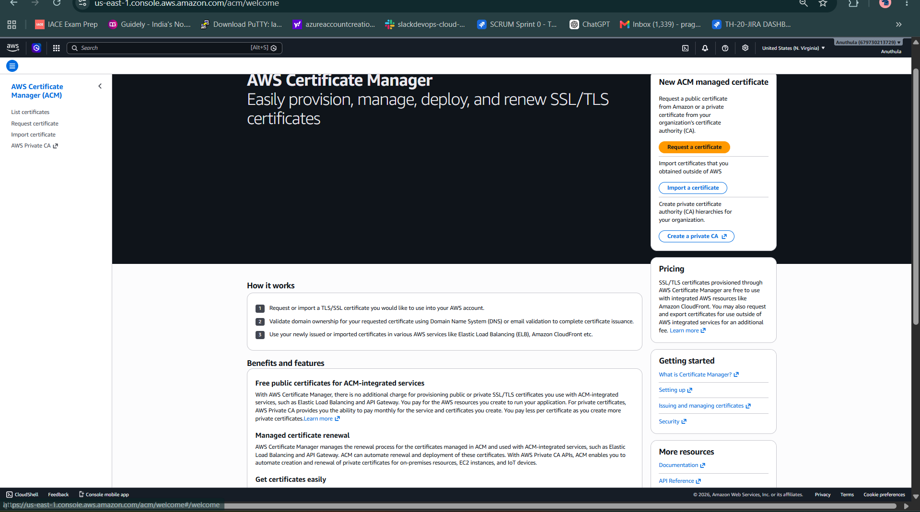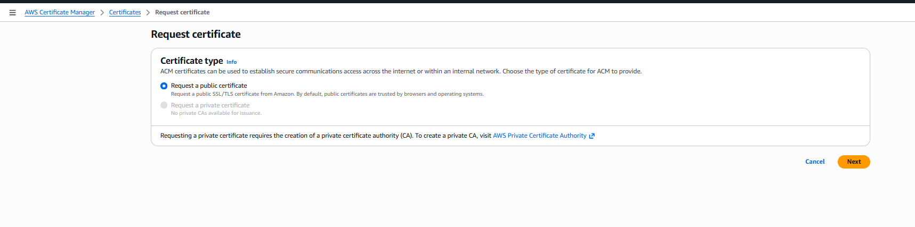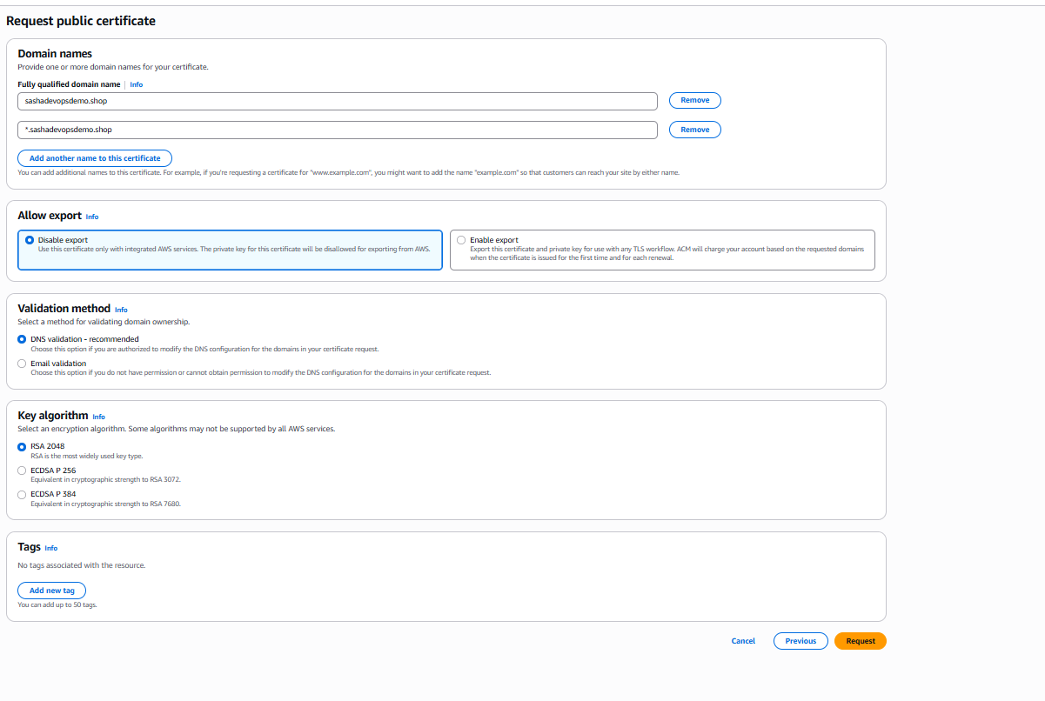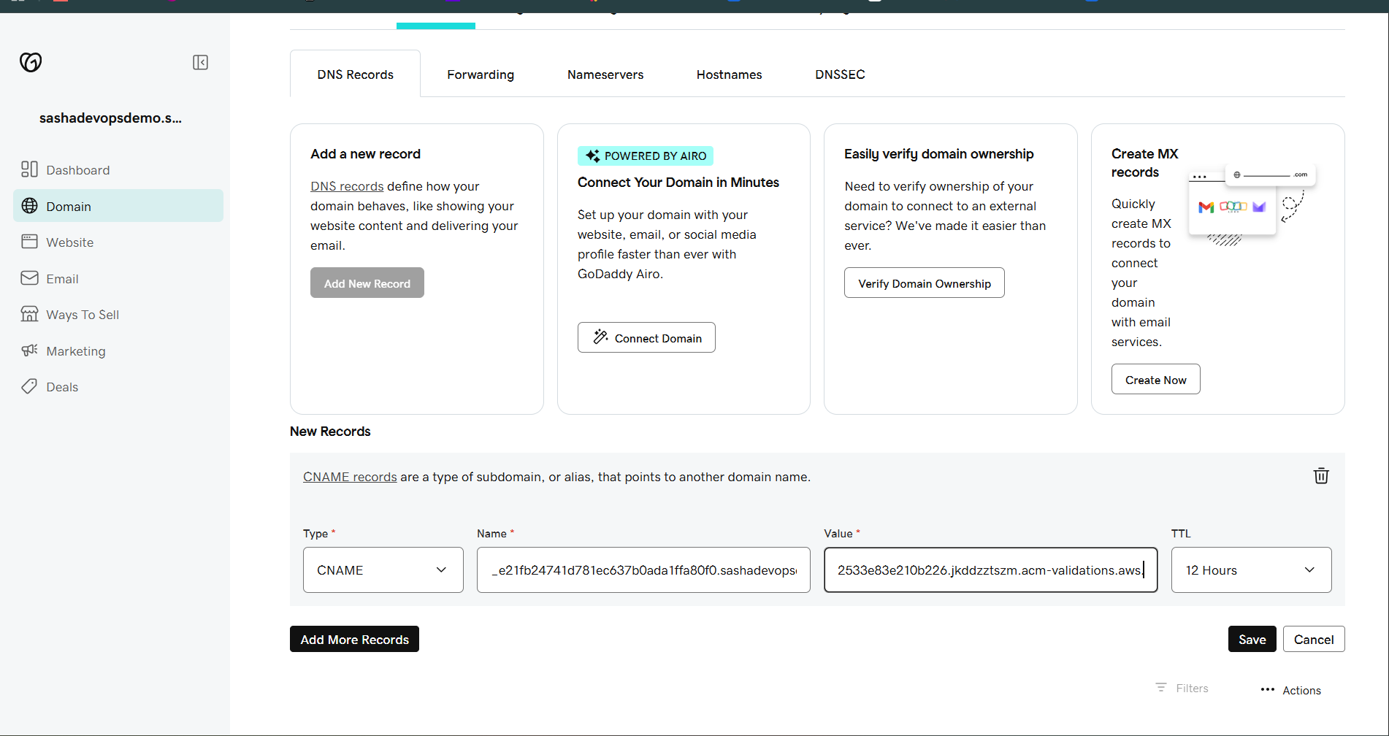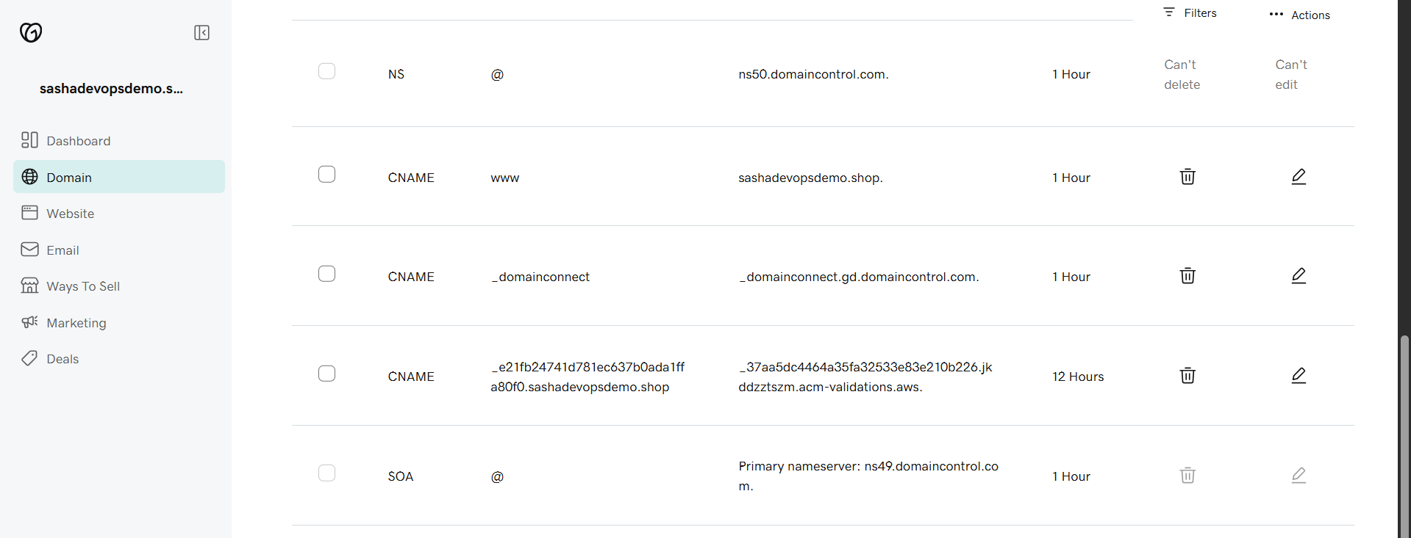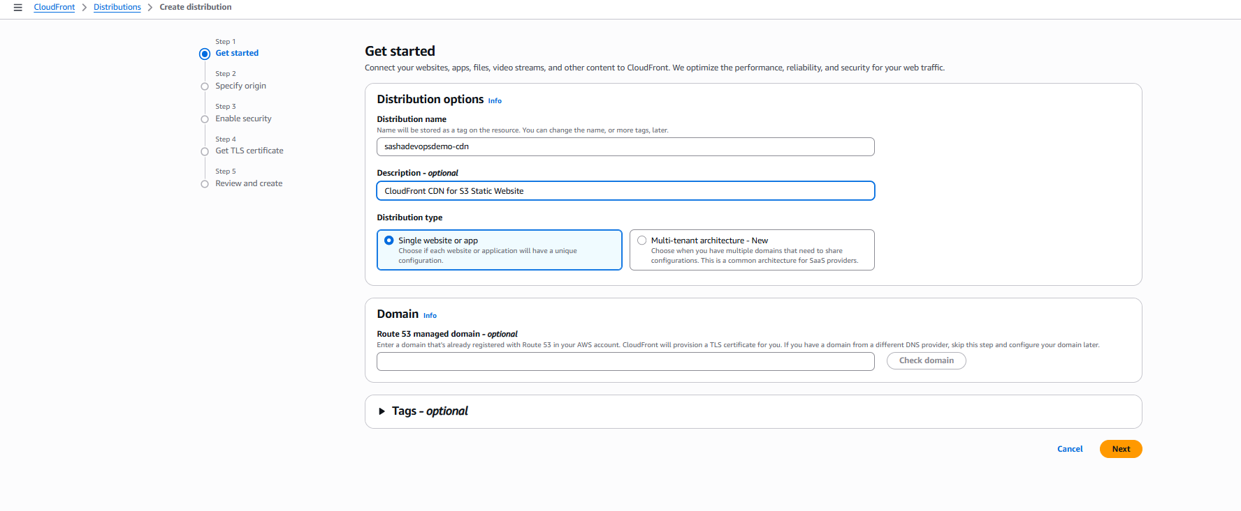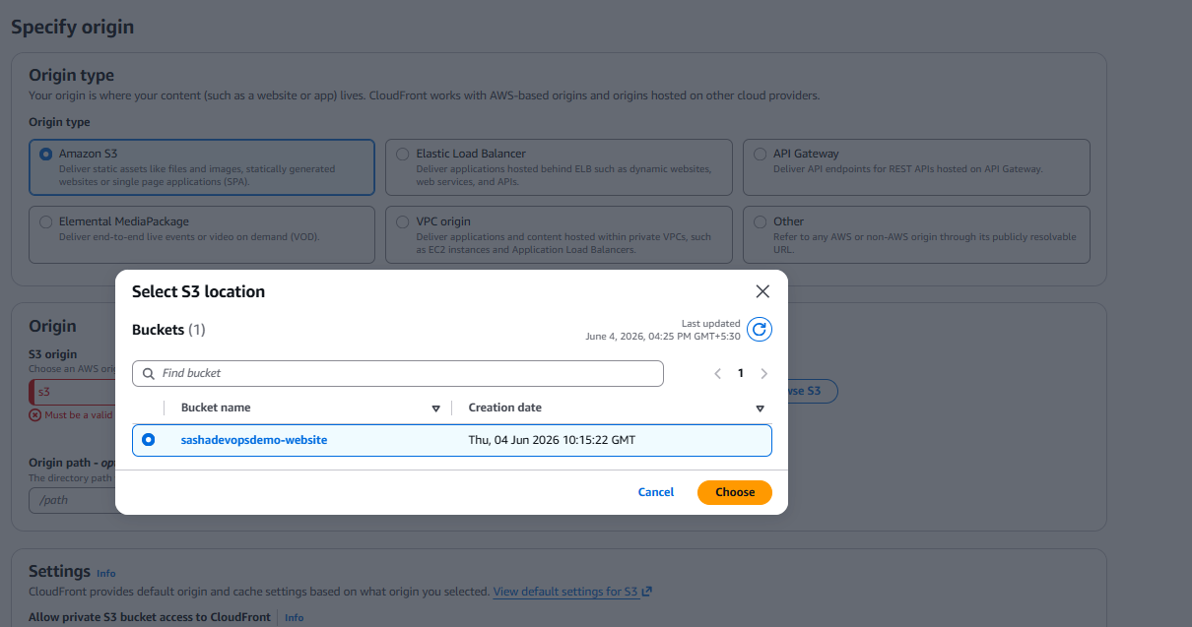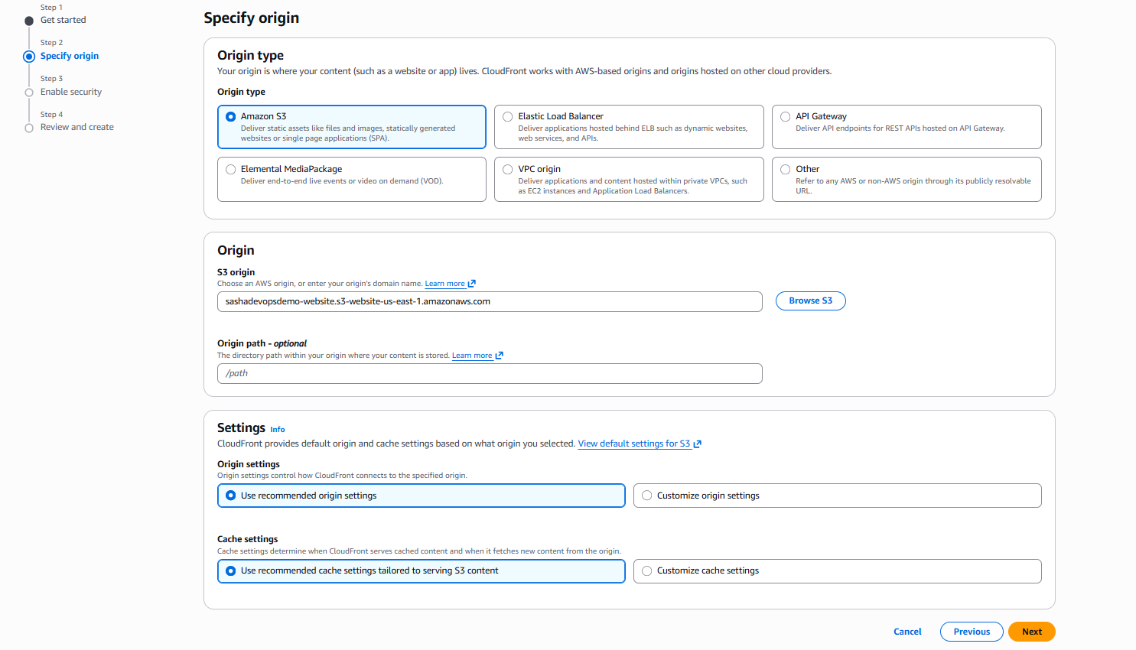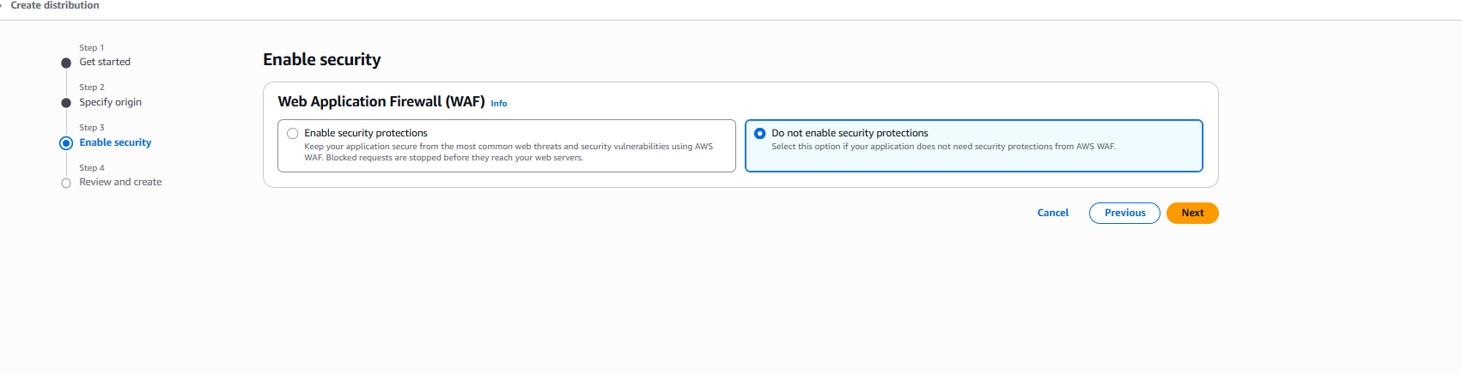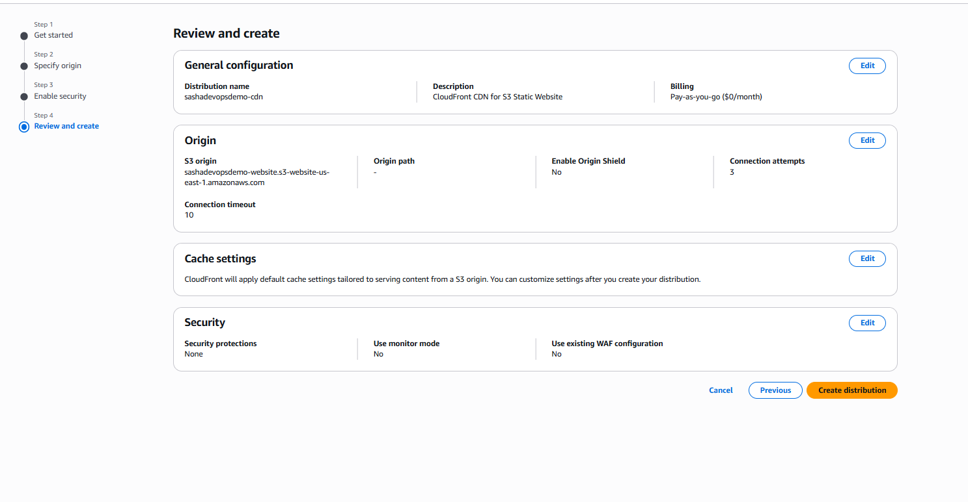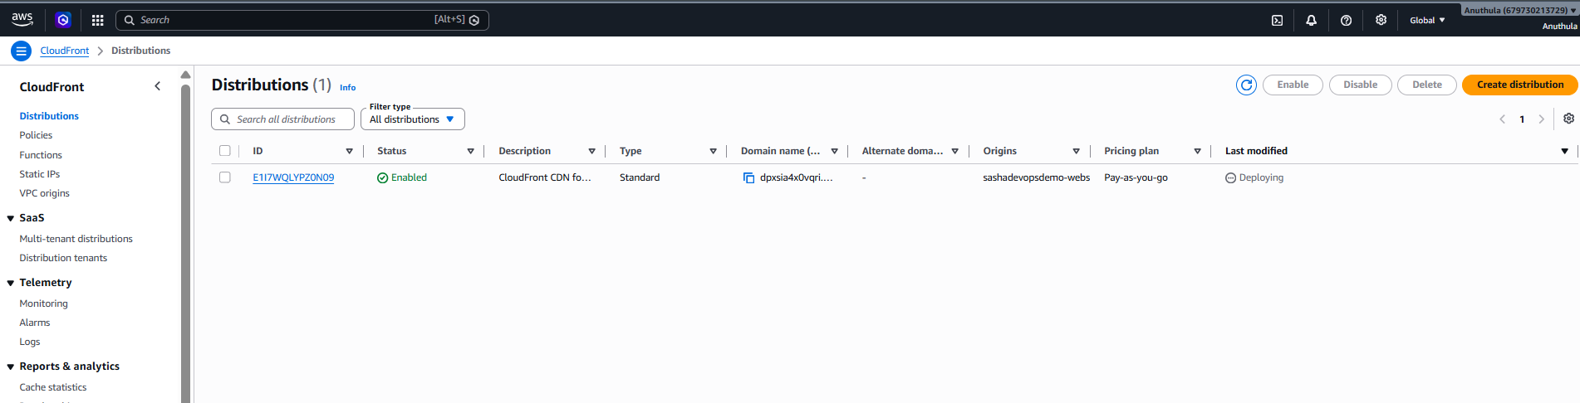

Task 5: Create a Route 53 Hosted Zone and Map the Domain with the CDN
Objective
The goal of this task is to use Route 53 to connect the custom domain with the CloudFront CDN.
Steps
Step 1: Create Hosted Zone
- Open Route 53.
- Click Hosted Zones.
- Click Create hosted zone.
- Enter domain name:
sashadevopsdemo.shop
- Choose Public hosted zone.
- Click Create hosted zone.
Route 53 automatically creates:
- NS record
- SOA record
Step 2: Copy Route 53 Nameservers
Inside hosted zone, copy the nameservers:
ns-1255.awsdns-28.org
ns-879.awsdns-45.net
ns-40.awsdns-05.com
ns-1619.awsdns-10.co.uk
Step 3: Update Nameservers in GoDaddy
- Open GoDaddy.
- Go to Domain Portfolio.
- Select:
sashadevopsdemo.shop
- Go to DNS → Nameservers.
- Replace GoDaddy nameservers with Route 53 nameservers.
- Save changes.
After this, DNS is managed by AWS Route 53.
Step 4: Add Custom Domains in CloudFront
- Open CloudFront distribution.
- Click Add domain.
- Add:
sashadevopsdemo.shop
www.sashadevopsdemo.shop
- Select SSL certificate.
- Click Add domains.
- Wait until distribution is deployed.
Step 5: Create Root Domain A Alias Record
- Go to Route 53 → Hosted Zones.
- Open:
sashadevopsdemo.shop
- Click Create record.
- Leave record name blank.
- Record type:
A
- Turn Alias ON.
- Route traffic to:
Alias to CloudFront distribution
- Select CloudFront domain:
dpxsia4x0vqri.cloudfront.net
- Click Create records.
Step 6: Create WWW A Alias Record
- Click Create record again.
- Record name:
www
- Record type:
A
- Turn Alias ON.
- Route traffic to:
Alias to CloudFront distribution
- Select:
dpxsia4x0vqri.cloudfront.net
- Click Create records.
Step 7: Verify Records
Final Route 53 records should include:
- A record for sashadevopsdemo.shop
- A record for www.sashadevopsdemo.shop
- NS record
- SOA record
- ACM validation CNAME records
Result
The domain was successfully mapped to CloudFront CDN using Route 53.
he custom domain name.
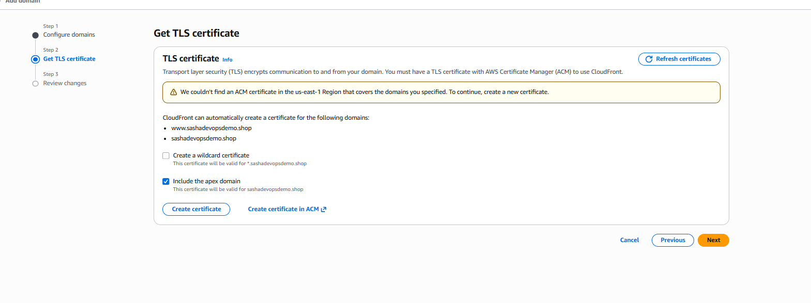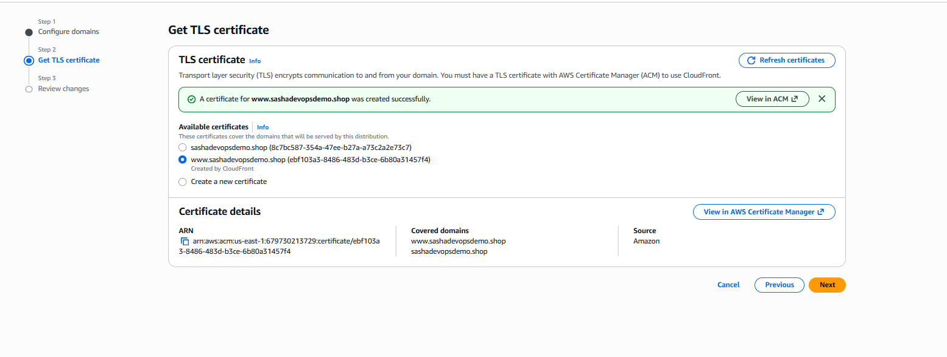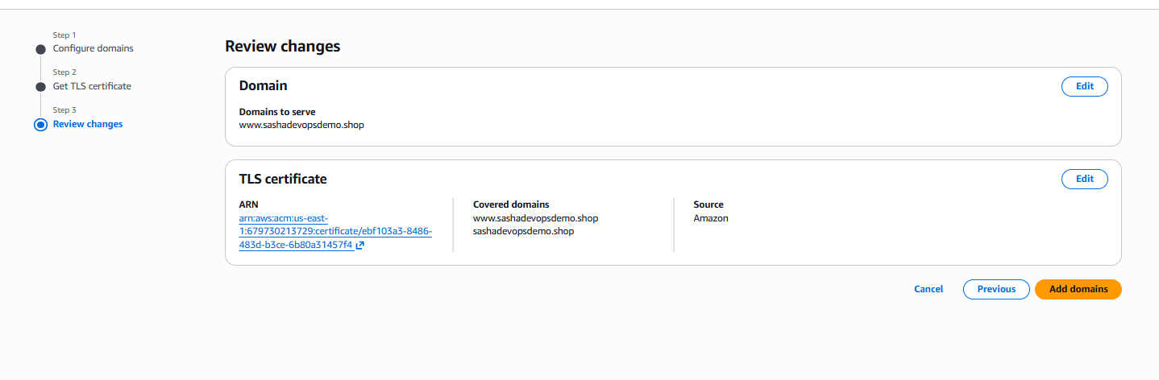
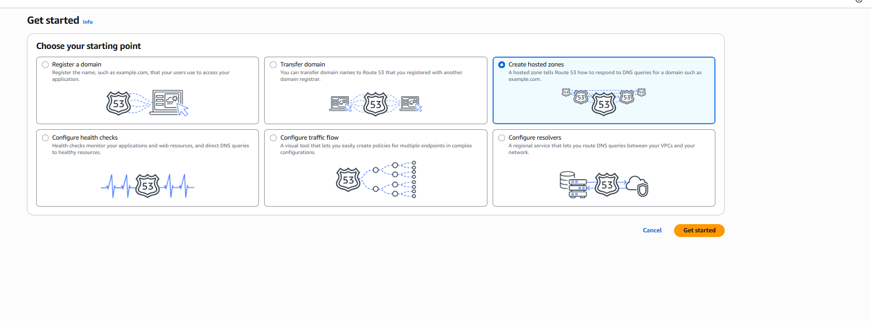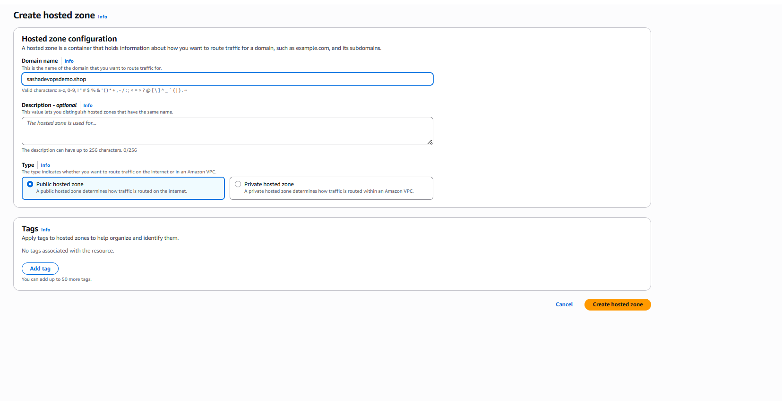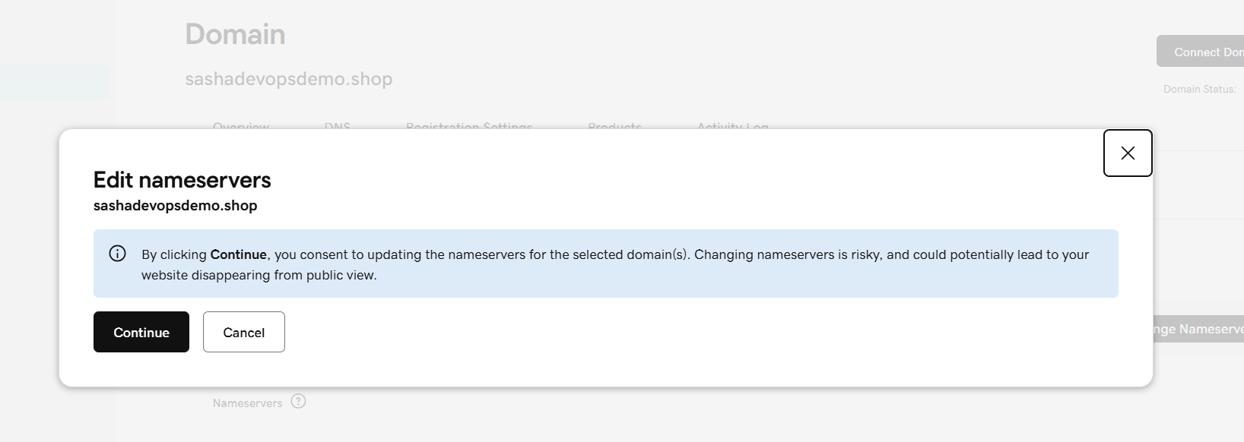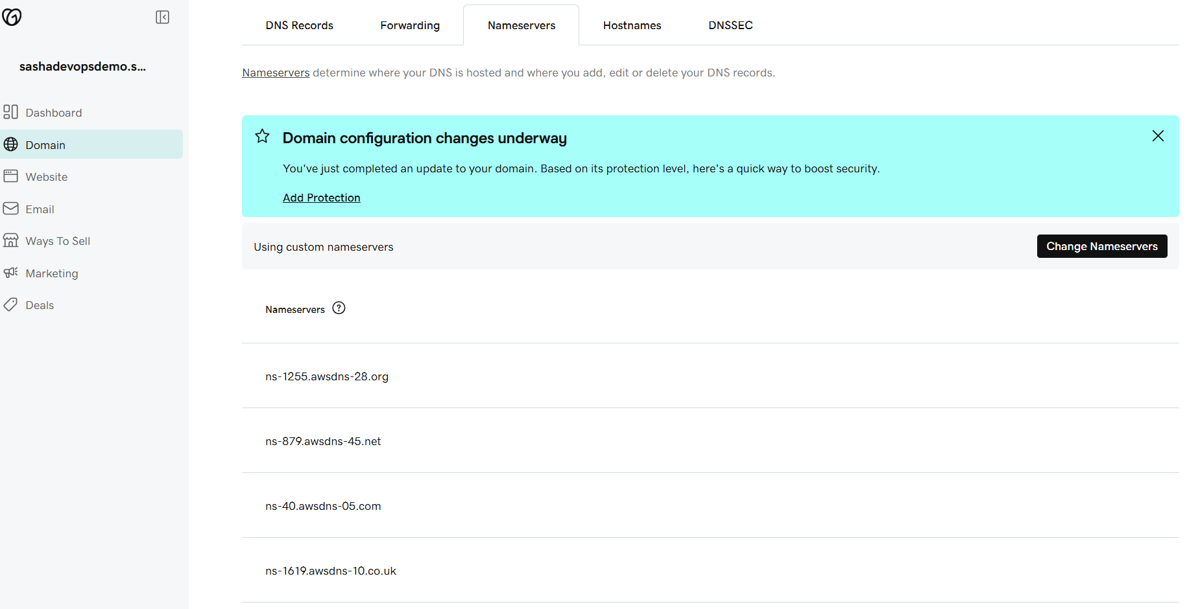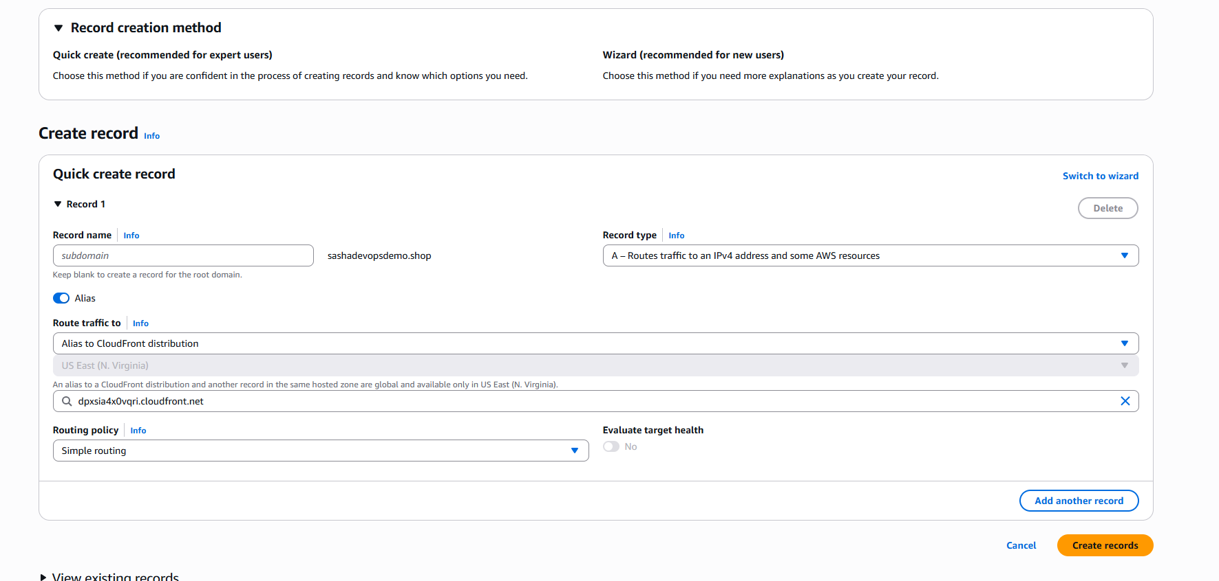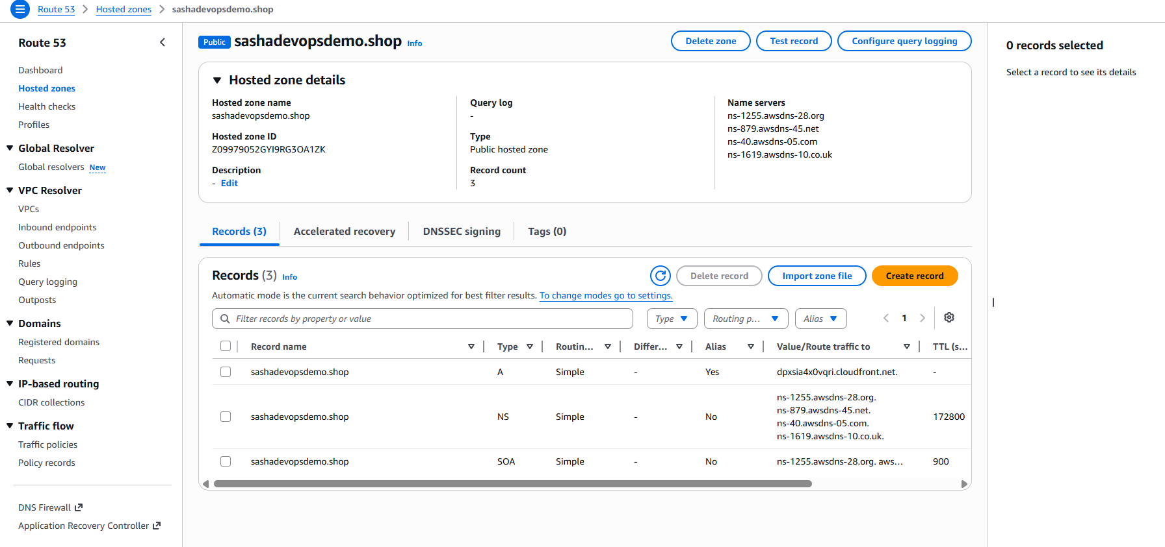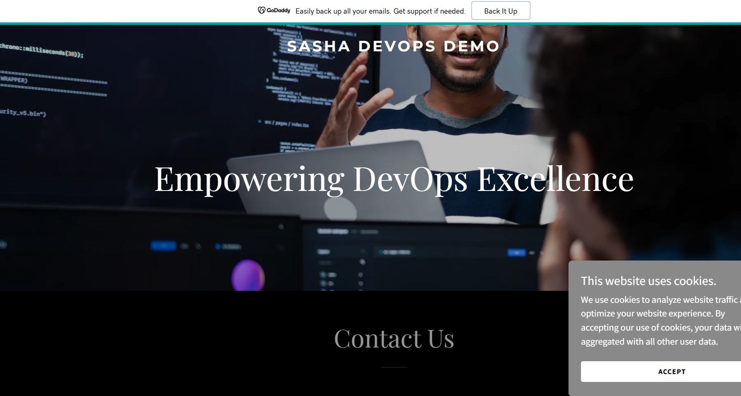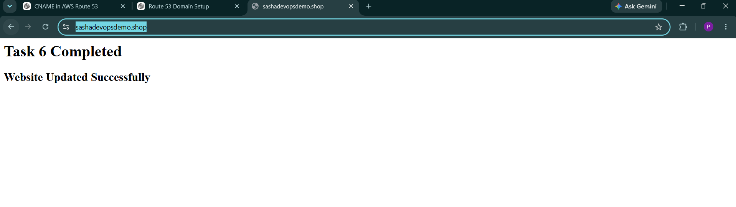

6-Task Name: Update the index.html in the S3 Bucket and Ensure the Updated File is Accessible Using the Domain Name
Objective:
To update the website content hosted in the Amazon S3 bucket and verify that the modified content is accessible through the custom domain configured with Route 53 and CloudFront.
Steps Performed:
- Accessed the S3 bucket hosting the static website.
- Downloaded and modified the existing index.html file.
- Updated the website content with new HTML text.
- Uploaded the modified index.html file to the S3 bucket, replacing the previous version.
- Opened the CloudFront distribution and created an invalidation request using /* to clear cached content.
- Waited for the invalidation process to complete.
- Accessed the website using the custom domain name.
- Verified that the updated content was displayed successfully.
Result:
The index.html file was successfully updated in the S3 bucket. After clearing the CloudFront cache through invalidation, the updated website content became accessible through the custom domain.
Conclusion:
The website content was successfully modified and deployed using Amazon S3. CloudFront served the latest version of the website after cache invalidation, and the updated content was verified through the domain name. 